**Summary**

With the rapid development of autonomous driving technology, there is a growing need for collection and sending of accurate road data. Deploying smart lampposts is an ideal and powerful solution. Lampposts can be modified and so are equipped with sensors and WiFi access points, the former of which collects data of moving objects and uploads them onto cloud server, and the latter of which downloads the data and sends them to vehicles. The lamppost system can greatly contribute to the L3 Autonomous Driving technology.

Our first model aims at evaluating lamppost modification plans. We include in the factors cost, WiFi supporting index and sensor cover index. These factors evaluate the modification plan’s ability to support daily traffic flow and that at the peak of a week. The evaluation model eventually outputs an array describing the features of a given smart lamppost modification plan.

The second model gets the best modification plan for a given area in Hong Kong. We separate the roads into many sections. According to data from online maps, we calculate the peak number of vehicles in each section, and in turn calculate each’s needed throughput. Finally we can get the best positions of WiFi-equipped lampposts through programming. Sensors (LiDARs) should cover all crosswalks, and as many road sections as possible, while balancing the total cost.

Then we evaluate our modification plan by our first model. Total cost is easy to calculate. With data of peak traffic flow from online maps, we can get the WiFi supporting index, both peak one and average one. By all these five factors, we evaluate our model. [evaluation result]

**Contents**

1 Introduction 3

2 Problem Restatement 3

3 General Assumptions 3

4 Evaluation Model 4

4.1 Key Factors 4

4.1.1 Cost Performance Rating (CPI) 4

4.1.2 WiFi Support Index (W) 5

4.1.3 Sensor Cover Index (S) 6

4.2 Model Output 7

5 Modification Plan Design 7

5.1 General 7

5.2 Cost Performance Rating 8

5.3 WiFi Support Index 8

5.4 Sensor Cover Index 11

6 Modification Plan Evaluation 14

6.1 Evaluation 14

6.2 Strengths 14

6.3 Weaknesses 15

6.4 Improvement **错误!未定义书签。**

References 15

# Introduction

As technology develops, autonomous driving is gradually coming to public notice. However, the lack of ways of collecting accurate road data and sending them to vehicles greatly hinders its development. Currently existing lampposts can be modified so that they are able to collect data from road and upload them onto servers, or send information to autonomous vehicles, which is an ideal solution to the current problem.

Our work aims to create methods to evaluate given lamppost modification systems, and decide a best lamppost modification plan for a particular limited city area. Then we evaluate our own modification plan and find out ways to improve it.

Our work helps analyze the ideal smart lamppost modification plan. It helps improve the modification plan and can tell developers its strengths and weaknesses, contributing to the realization of L3 Autonomous Driving technology.

# Problem Restatement

The first model aims at evaluating given modification systems. We consider five main factors: WiFi support index, cost and sensor cover index. The model outputs an array at last as the evaluation of the modification plan.

The second model helps develop the best lamppost modification plan for a particular area in Hong Kong. We separated the roads in the area into several sections and calculate the traffic flow of each section and get the required throughput of each section. In that way we can get the best location of smart lampposts equipped with WiFi access points. As sensors need to cover all crosswalks, no buildings, and as many roads as possible and balance with cost, we can calculate their locations by a similar method.

Finally we need to evaluate our own modification plan with the evaluation model, which shows the pros and cons of a modification plan. By applying our plan to it, we can see how to improve our solution.

# General Assumptions

1. All vehicles are L3 autonomous vehicles.
2. Drivers can’t operate the vehicle when it is driving autonomously.
3. The data a vehicle needs to receive at one time is 4Mb in size.

# Evaluation Model

## Key Factors

### Cost Performance Rating (CPI)

refers to the number of lampposts with sensors only, to that with WiFi access point only, and to that with both. Since the CPI of lampposts with both sensor and WiFi access point is hard to calculate using the following mechanism, we consider the cost impact of a lamppost with both sensor and WiFi access point the same as 1.25 lampposts with sensor plus 1.25 lampposts with WiFi access point. The mechanism is shown below.

stands for the total length of all roads in the district and for the area of the selected district. and are scale factors adjusting the weights of sensors and WiFi access points.

In the ideal situation in which the locations of roads are just perfect, all area is within range of sensor and WiFi access point and CPI should be 1.00, there is no overlapping area for either sensor or WiFi access point, and there is no lamppost with both sensor and WiFi access point. We consider sensor and WiFi access point the same weight. In every area, in which

(estimated)[1]

*The left side is the CPI of a modification plan in which sensors are perfect and there are only half of the WiFi access points needed, and the right side vice versa.

### WiFi Support Index (W)

We number the lampposts from 1 to . The WiFi Support Index of Lamppost is marked as . Concerning the problems such like WiFi instability and packet loss, we consider the usable throughput of a lamppost with WiFi-access-point 600 Mbps, 75% of maximum throughput. So the number of vehicles receiving data equals . We suppose that vehicles in the overlapping area of multiple WiFi access points are equally distributed to the lampposts to transport data.

So, given the number of vehicles in the access range of lamppost (),

To emphasize the impact of low WiFi support index,

### Sensor Cover Index (S)

For the general cover rate:

stands for the sensor cover road length.

As the crosswalk cover rate is extra important, since its great influence on pedestrians’ safety, we take into account Crosswalk Cover Rate (C).

stands for the number of sensor-covered crosswalks, and for the total number of crosswalks.

Consider

So,

To emphasize the extra importance of crosswalk cover rate,

Obviously, and are monotonically increasing, and

is quite ideal in this situation. The function’s framework can be:

The scale factor and the intercept is used to control the order of magnitude of to meet the range of . So it can be discussed later.

Since and have similar feature , and (0,0) and (1,1) are on both functions’ images, they can be concluded as

One possible solution is that:

Since the range of and are both [0,1], and is just ideal.

## Model Output

The model eventually outputs an array () indicating the WiFi and sensor cover condition and the total price of the modification plan.

# Modification Plan Design

## General

We assume that pedestrians never choose to go over separating facilities such as fences for the purpose of illegally crossing roads.

We select a district about in Hong Kong and divide it into several sections by crossroads. Data are collected from Hong Kong GIS and Google Map, including the daily traffic flow, locations of lampposts and crosswalks and the size of area and sections. We establish a plane space right angle coordinate system as shown below.

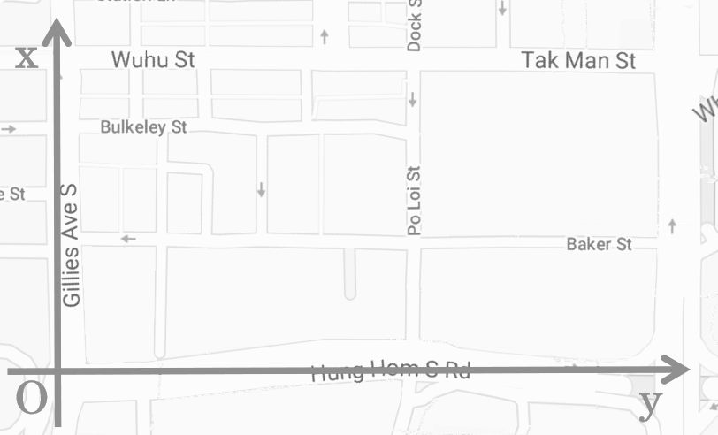

## Cost Performance Rating

The overall cost undoubtedly plays an important role in the evaluation. Since the distance between neighboring lampposts is short, and the cost of a lamppost with sensor + WiFi-Access-Point is appreciably greater than one with sensor plus one with WiFi-Access-Point, we avoid employing lampposts with both sensor and WiFi-Access Point, and equipping neighboring lampposts with one sensor and one WiFi-Access-Point instead.

[]

## WiFi Support Index

We see every road section as a section point at the mid of the section. Each of these points contain a number which stands for the number of vehicles moving in that section. However, some road sections are so long that its length cannot be ignored. To solve this problem, we separate some long sections equally into some short ones which have the same length and vehicle density.

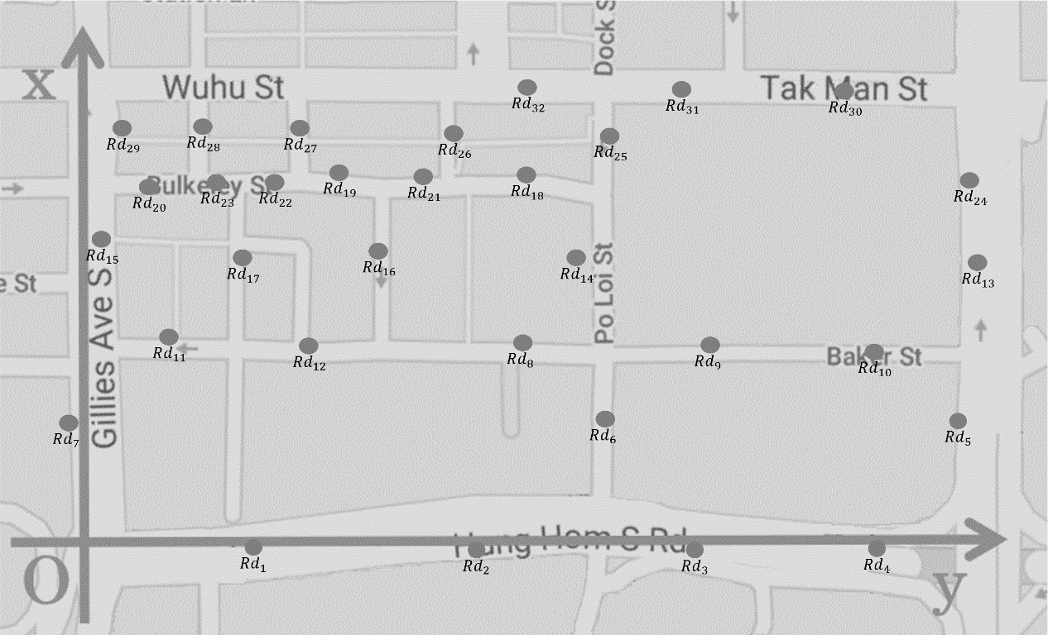

We collected from the Internet the peak total vehicle number, the locations of lampposts, and the road sections’ colors which indicates its vehicle density. So we in turn get the proportion of vehicles of each section on average.

We consider the situation when the total vehicle number is that at peak and the proportion of each section is on average. According to the data and the algorithm below, there is about 920 vehicles in all.

|  |  |
| --- | --- |
| Color | Vehicle Density (Vehicles/Lane/m) |
| Green | 0.04 |
| Yellow | 0.1 |
| Red | 0.3 |

**Table 1.** Vehicle Density of different colors of Google Map’s traffic indicator

The algorithm below means that lampposts at least are needed. Considering the total area of the district, we estimate that 6-9 smart lampposts with WiFi access point are required.

By enumerating all the possible locations of lampposts with WiFi access points, we can get the maximum of WiFi Support Index with any given . By running the program four times with , we get the ideal WiFi-Access-Point employment plan for four values of . The following algorithms are under the premise that all road sections are within the range of at least one WiFi access point.

By programming, we get that:

|  |  |  |
| --- | --- | --- |
|  | Number of Optimal Solutions |  |
| 6 | 0* | / |
| 7 | 2 | 0.922749 |
| 8 | 1942 | 1 |
| 9 |  | 1 |
| *There is no solution in which all sections are covered when . | | |

**Table 2.** and the number of optimal solutions with different

Obviously, the solutions are the optimal ones for the district. Since the 1942 optimal solutions are equivalent within the selected district, we consider the solution with the biggest total cover area (both within and outside the selected district) the best one. We compare the total cover area of the solutions by the lampposts’ average distances from the district’s geometric center. The lampposts’ coordinates and locations on the map are shown below.

|  |  |  |  |  |  |  |  |  |
| --- | --- | --- | --- | --- | --- | --- | --- | --- |
| (m) | 0 | 0 | 25 | 113 | 127 | 196 | 240 | 245 |
| **(m)** | 242 | 397 | 27 | 390 | 57 | 234 | 40 | 425 |

**Table 3.** Coordinates of WiFi lampposts in the optimal solution

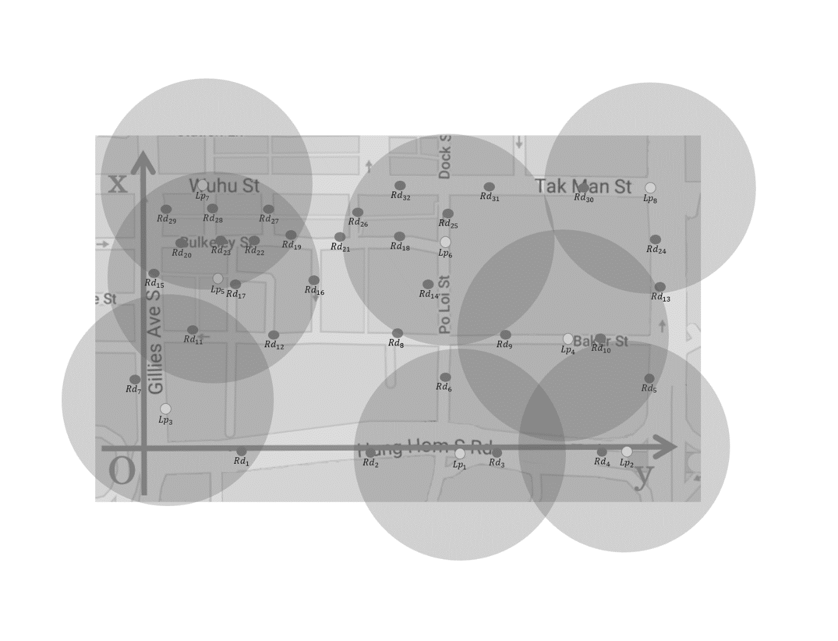

## Sensor Cover Index

Noticing that one lamppost with sensors can only cover , T-junctions and intersections are equivalent in our model. As sensor signals cannot pass through buildings, employing lampposts with sensors at crossroads are better than elsewhere. As sensors at T-junctions cover more road sections, we choose to employ LiDARs at T-junctions, and then on the roads. All T-junctions (and intersections) are marked in the figure below.

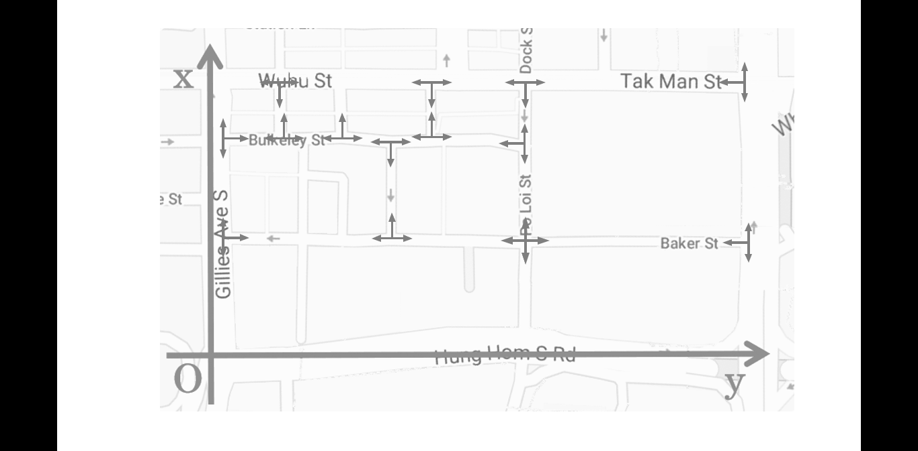

After employing sensors at all T-junctions, we find that there are two equivalent solutions, in each of which one more lamppost with sensors is required. At present, and obviously haven’t reach the target value.

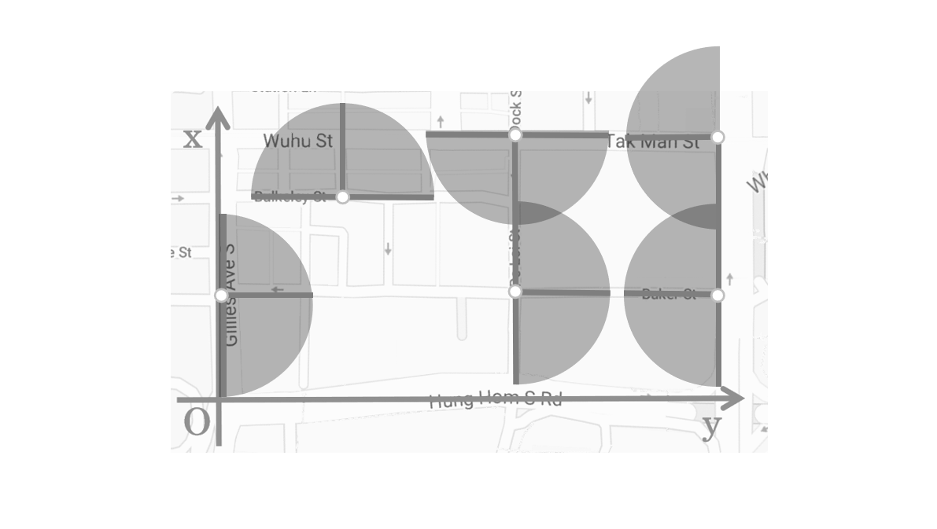

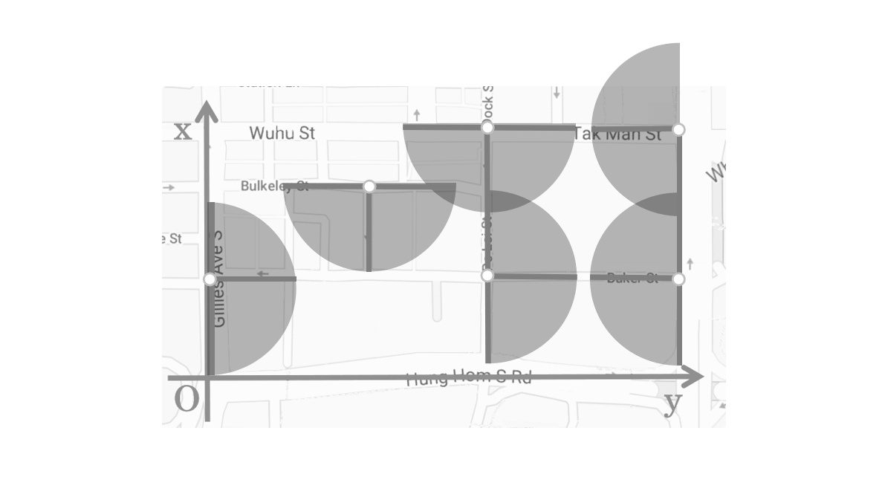

After employing the last smart lampposts, reaches 1.00 and reaches 0.857854.

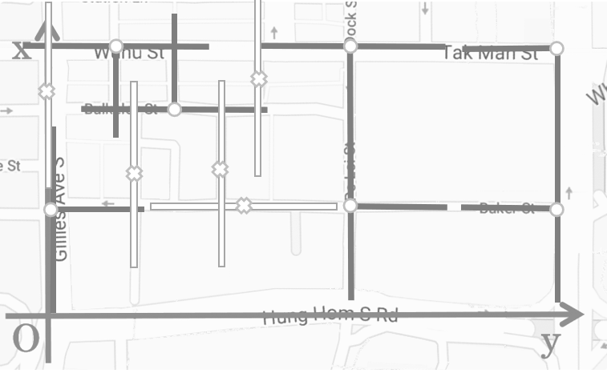

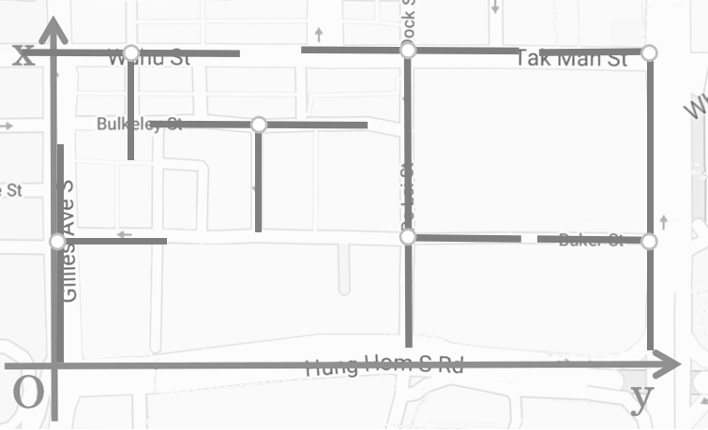

The solution above owns 0.14214576 of road length, about 314m out of the sensor range. After programming, we prove that adding an extra lamppost equipped with sensor isn’t worthwhile, which means that the current solution is the optimal one.

# Modification Plan Evaluation

## Evaluation

By applying to our evaluation model our smart lamppost modification plan for the district in Hong Kong, we can get the following array.

## Strengths

The WiFi access point employment is almost ideal. Our program calculated the best solution for the peak number of vehicles at the average proportion of week. We also take into consideration the total WiFi access area, both within the selected district and outside, making it not limited within the narrow districted, comparing to the whole city, selected.

## Weaknesses

The sensors have too much overlapping space, causing the extreme waste of sensor detecting range. The map is shown below.

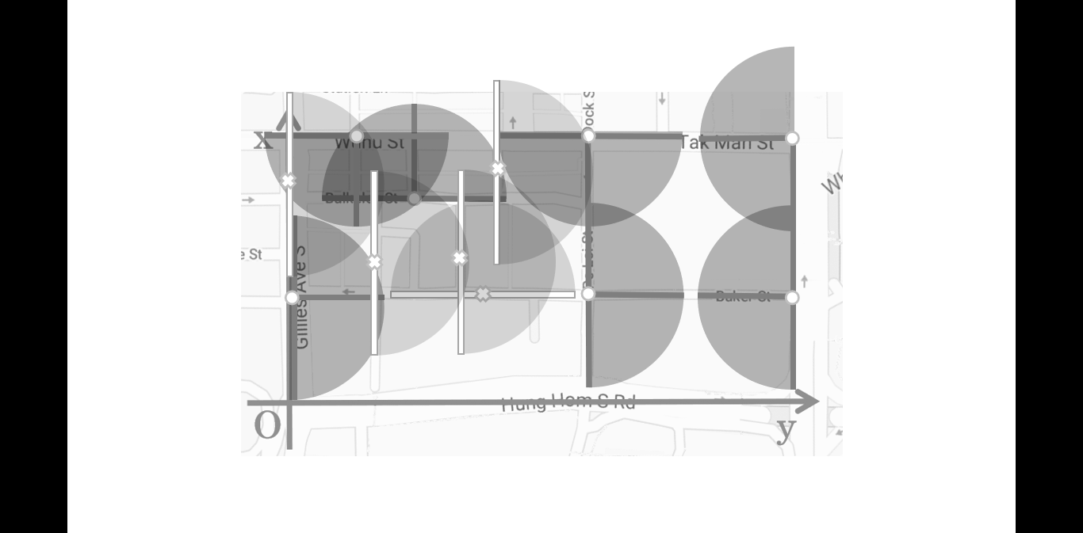

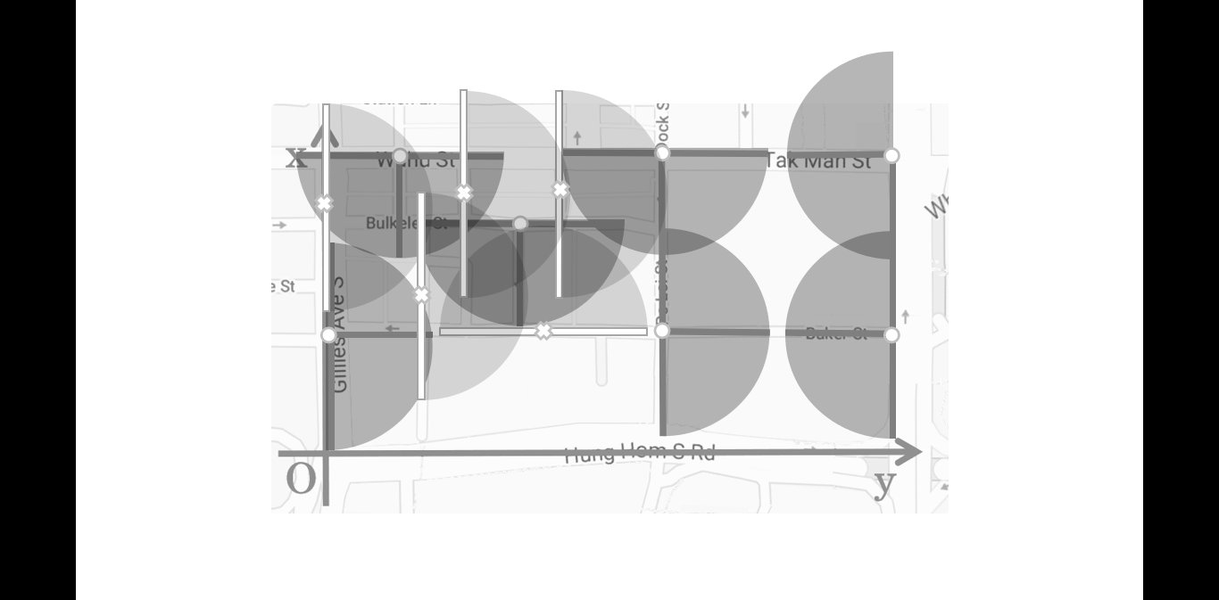

We can see that a very large detecting area of sensors is wasted. This is caused by the fact that buildings can block the signal of sensors.

# References

1. https://www.google.com/maps/@22.3057874,114.1862536,17z
2. https://www.map.gov.hk/gm/map

1.